Question 1:

#include <stdio.h>

int main() {

int arr[100], size;

int \*ptr, sum = 0;

printf("Enter the size of the array: ");

scanf("%d", &size);

printf("Enter array elements: ");

for (int i = 0; i < size; i++) {

scanf("%d", &arr[i]);

}

ptr = arr;

for (int i = 0; i < size; i++) {

sum = sum + \*ptr;

ptr++;

}

printf("The sum of array elements is: %d", sum);

return 0;

}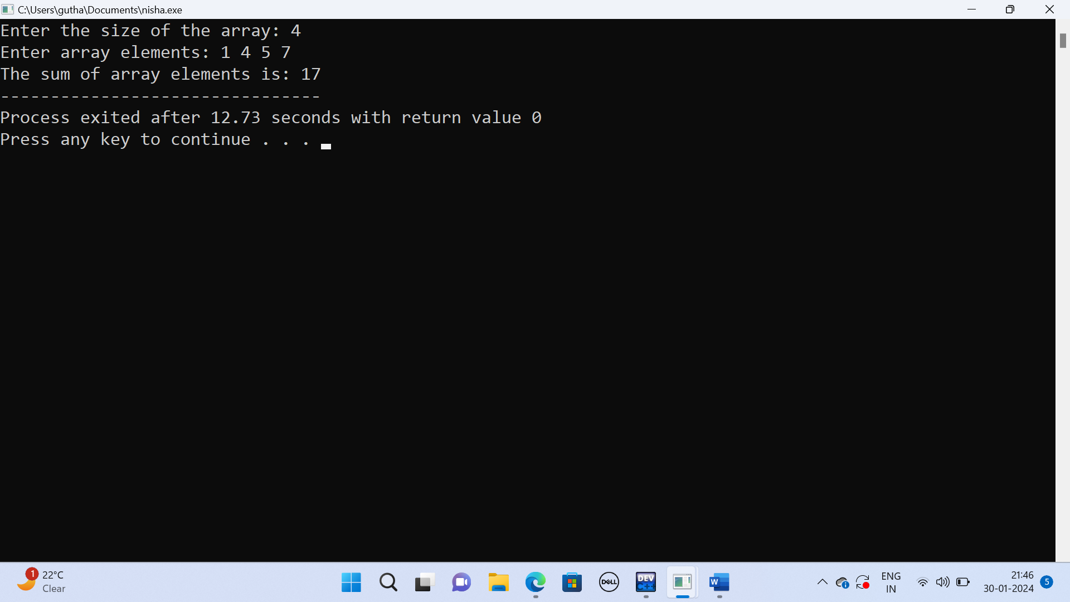

Question 2:

#include<stdio.h>

void swapnumbers(int\*ptr1,int\*ptr2)

{

int temp;

temp=\*ptr1;

\*ptr1=\*ptr2;

\*ptr2=temp;

}

int main()

{

int num1,num2;

printf("enter two numbers :");

scanf("%d %d",&num1,&num2);

swapnumbers(&num1,&num2);

printf("the swapped numbers are =%d %d ",num1,num2);

}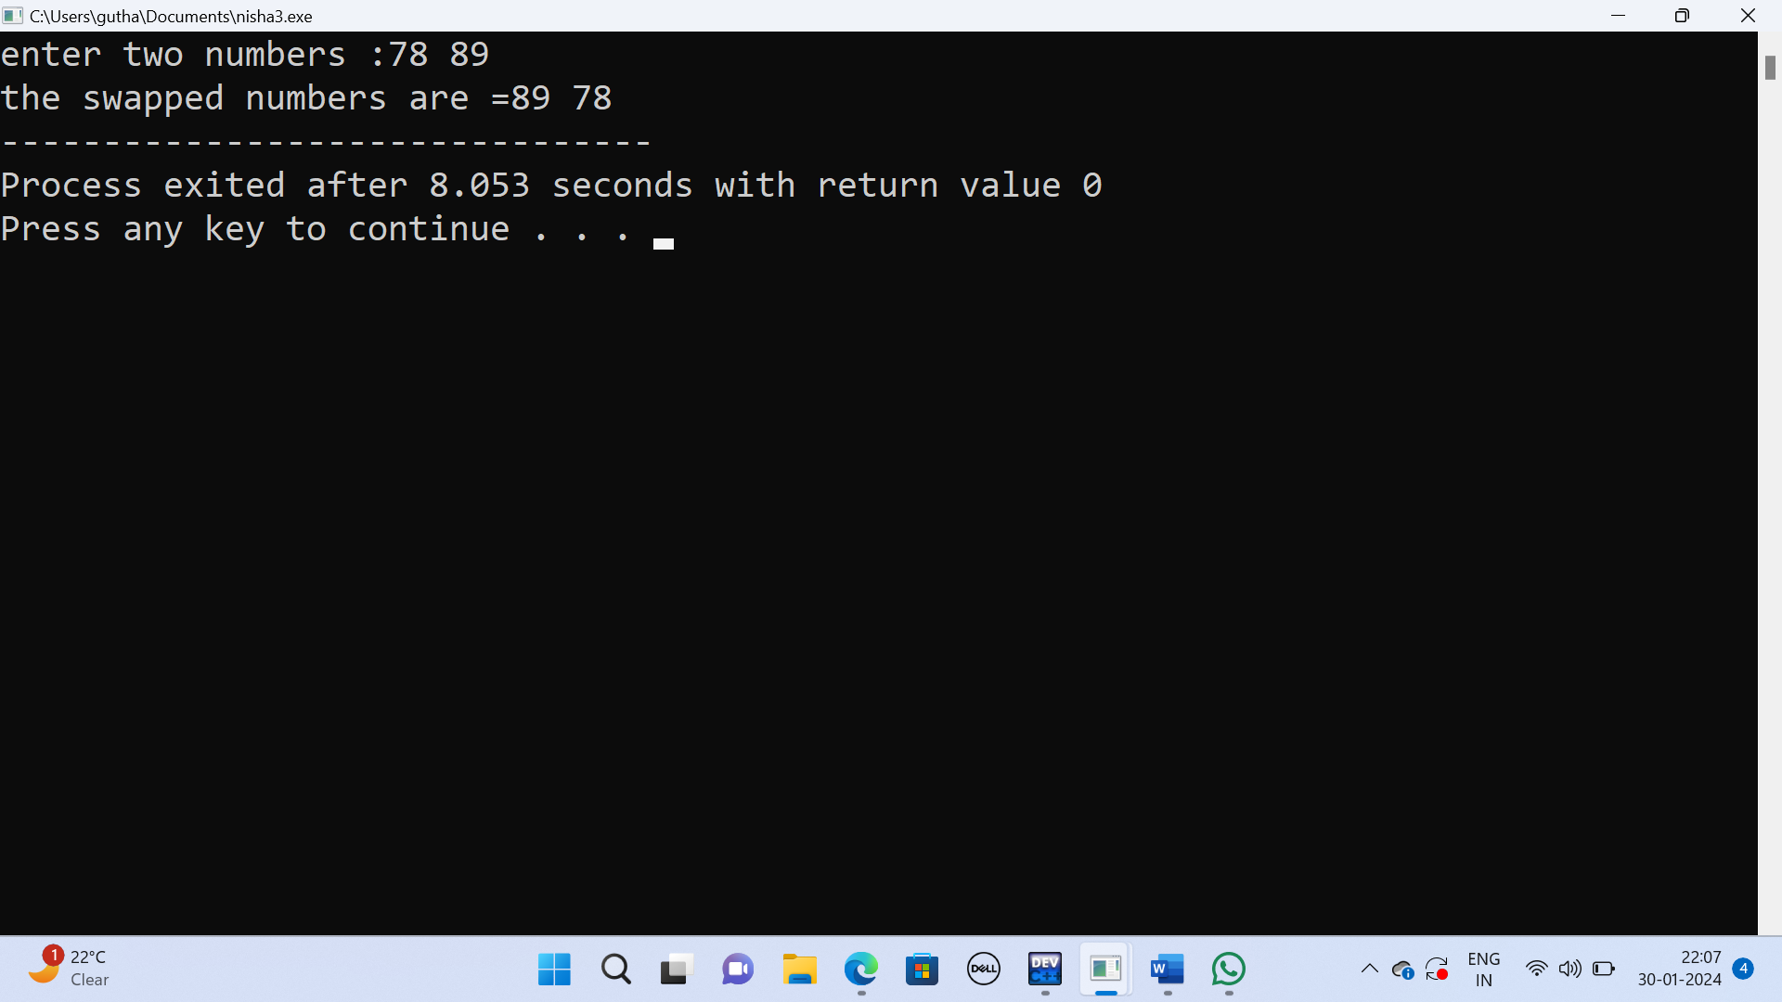

Question 3:

#include <stdio.h>

void reverseString(char \*start) {

char \*end = start, temp;

while (\*end) {

end++;

}

end--;

while (start < end) {

temp = \*start;

\*start = \*end;

\*end = temp;

start++;

end--;

}

}

int main() {

char input[100];

printf("Enter a string: ");

gets(input);

reverseString(input);

printf("Reversed string: %s\n", input);

return 0;

}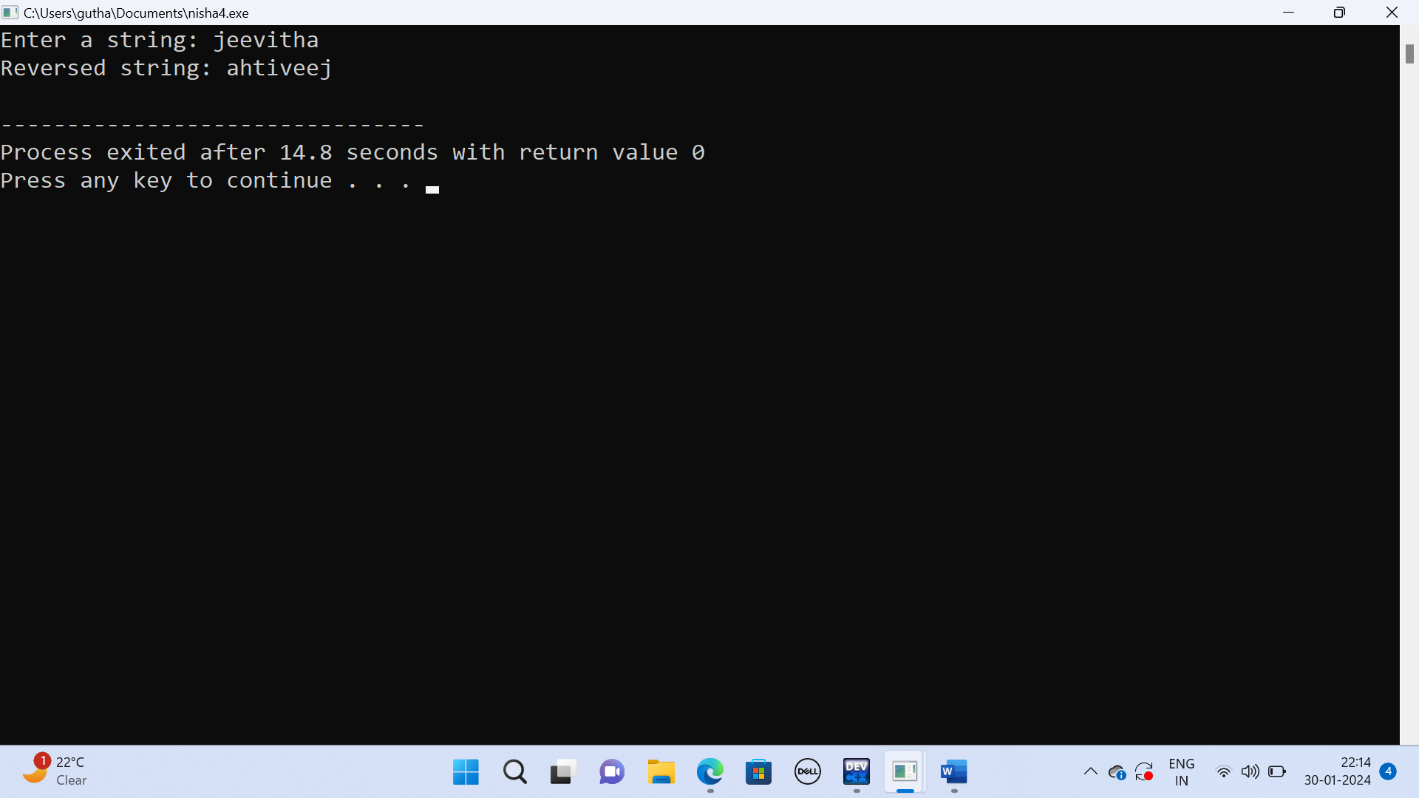

Question 4:

#include <stdio.h>

int power(int n1, int n2);

int main() {

int base, a, result;

printf("Enter base number: ");

scanf("%d", &base);

printf("Enter power number(positive integer): ");

scanf("%d", &a);

result = power(base, a);

printf("%d^%d = %d", base, a, result);

return 0;

}

int power(int base, int a) {

if (a != 0)

return (base \* power(base, a - 1));

else

return 1;

}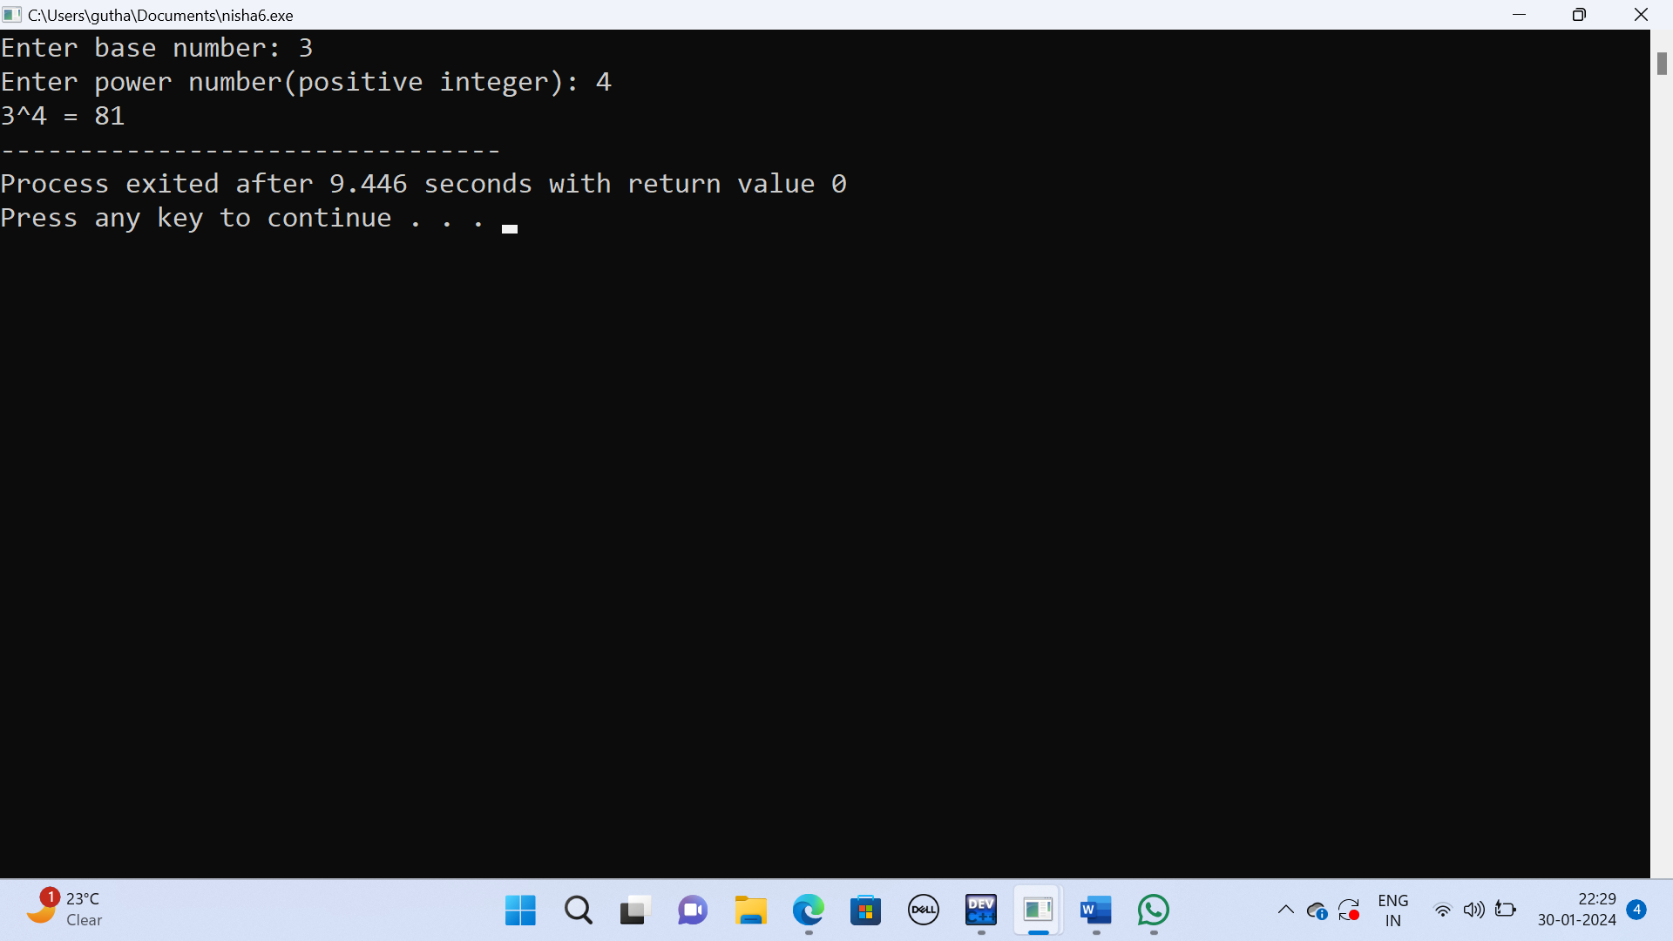

Question 5:

#include <stdio.h>

#include <stdlib.h>

int main() {

int rows, cols;

printf("Enter the number of rows: ");

scanf("%d", &rows);

printf("Enter the number of columns: ");

scanf("%d", &cols);

int \*\*matrix = (int \*\*)malloc(rows \* sizeof(int \*));

for (int i = 0; i < rows; i++) {

matrix[i] = (int \*)malloc(cols \* sizeof(int));

}

printf("Enter the elements of the matrix:\n");

for (int i = 0; i < rows; i++) {

for (int j = 0; j < cols; j++) {

scanf("%d", &matrix[i][j]);

}

}

printf("The entered matrix is:\n");

for (int i = 0; i < rows; i++) {

for (int j = 0; j < cols; j++) {

printf("%d\t", matrix[i][j]);

}

printf("\n");

}

for (int i = 0; i < rows; i++) {

free(matrix[i]);

}

free(matrix);

return 0;

}